**NAME…………………………………………………… ADM No……………………… Candidate’s Signature…………………INDEX No……………………………. Date………… 231/2**

**BIOLOGY**

April, 2023

**TIME: 2 HOURS**

**MOKASA I JOINT EXAMINATIONS**

**FORM 4**

**INSTRUCTIONS TO CANDIDATES**

1. Write your name and Index Number in the spaces provided above
2. This paper consists of two sections: **A** and **B**. Answer **ALL** questions in section **A** in the spaces provided. In section B, answer question 6 (compulsory) and either question 7 or 8 in the spaces provided after question 8.

**For Examiners’ use only**

|  |  |  |  |
| --- | --- | --- | --- |
| **Section** | **Questions** | **Maximum Score** | **Candidate’s Score** |
| **A** | 1 | 8 |  |
| 2 | 8 |  |
| 3 | 8 |  |
| 4 | 8 |  |
| 5 | 8 |  |
| **B** | 6 | 20 |  |
| 7 | 20 |  |
| 8 | 20 |  |
| **Total Score** |  | **80** |  |

1. 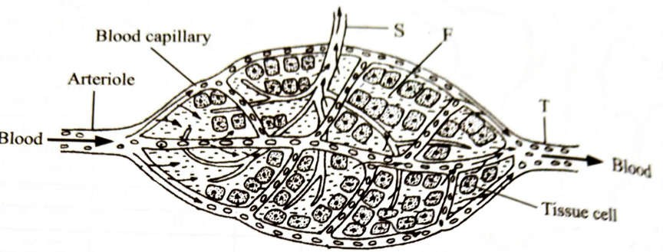The diagram below shows the site where exchange of substances takes place in the mammalian circulation.
   1. Name the vessels labelled S and T (2marks) S……………………………………………………………………………………………. T…………………………………………………………………………………………….
   2. Name the fluid labelled F and state its importance (2marks)

………………………………………………………………………………………………

………………………………………………………………………………………………

* 1. Name the :
     1. Respiratory substances that move out of the capillaries (1mark)

……………………………………………………………………………………………

* + 1. Respiratory end products that are removed from tissue cells (1mark)

………………………………………………………………………………………………

* 1. Name the blood cells that may be found in the fluid labelled F (1mark)

………………………………………………………………………………………………

* 1. Name components of blood that are not found in the fluid labelled F (1mark)

………………………………………………………………………………………………

…………………....................................................................................................................

1. In tulip plants, the petals can have markings called flecks. There are two alleles for flecks in tulip plants: with flecks **F**; and without flecks **f**.
2. Explain the meaning of the term dominant allele. (2 marks)

………………………………………………………………………………………………………

………………………………………………………………………………………………………

……………………………………………………………………………………………...............

1. A tulip grower crosses two tulip plants. He finds that 76 of the offspring have petals with flecks and 23 of the offspring have petals without flecks. Make a genetic cross to explain the results. (4 marks)

………………………………………………………………………………………………………

………………………………………………………………………………………………………

………………………………………………………………………………………………………

………………………………………………………………………………………………………

………………………………………………………………………………………………………

………………………………………………………………………………………………………

………………………………………………………………………………………………………

………………………………………………………………………………………………………

……………………………………………………………….

1. The tulip grower wants to produce a pure-breeding variety of tulips with petals without flecks. State the genotypes of the parent plants he should use to produce tulip plants without flecks. Explain your answer. (2 marks)
   1. Parental genotypes

………………………………………………………………………………………..……………

……………………………………………………………………………………………………..

* 1. Explanation

.……………………………………………………………………………………………………

……………………………………………………………………………………………………..

1. A freshly obtained dandelion stem measuring 5 cm long was split lengthwise to obtain two similar pieces. The pieces were placed in solutions of different concentrations in petri dishes (L.1 and L2) for 20 minutes. The appearance after 20 minutes is as shown

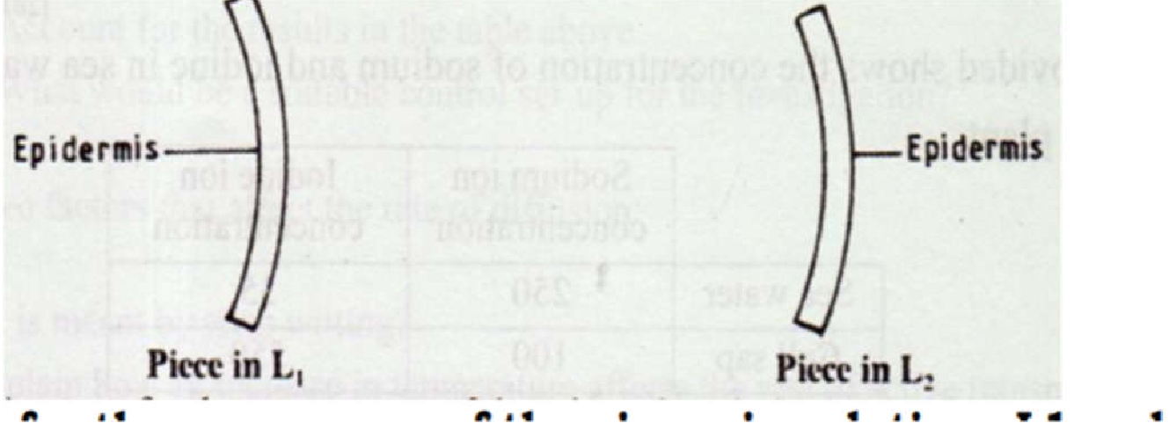

1. Account for the appearance of the pieces in solutions Ll and L2 (6 marks)

………………………………………………………………………………………………

………………………………………………………………………………………………

………………………………………………………………………………………………

………………………………………………………………………………………………

………………………………………………………………………………………………

………………………………………………………………………………………………

………………………………………………………………………………………………

………………………………………………………………………………………………

………………………………………………………………………………………………

……………………………………………………………………………………………….

1. State the significance of the biological process involved in the experiment in plants (2 marks)

………………………………………………………………………………………………

………………………………………………………………………………………………

………………………………………………………………………………………………

……………………………………………………………………………………………....

1. a) Describe the process of inhalation in mammals ( 4mrks)

………………………………………………………………………………………………

………………………………………………………………………………………………

………………………………………………………………………………………………

………………………………………………………………………………………………

………………………………………………………………………………………………

………………………………………………………………………………………………

………………………………………………………………………………………………

……………………………………………………………………………………………....

1. Explain two ways in which the following structure are adapted to gaseous exchange. (4mrks)
   1. Mesophyte leaf

………………………………………………………………………………………………

………………………………………………………………………………………………

* 1. Pneumatophores

………………………………………………………………………………………………

………………………………………………………………………………………………..

1. 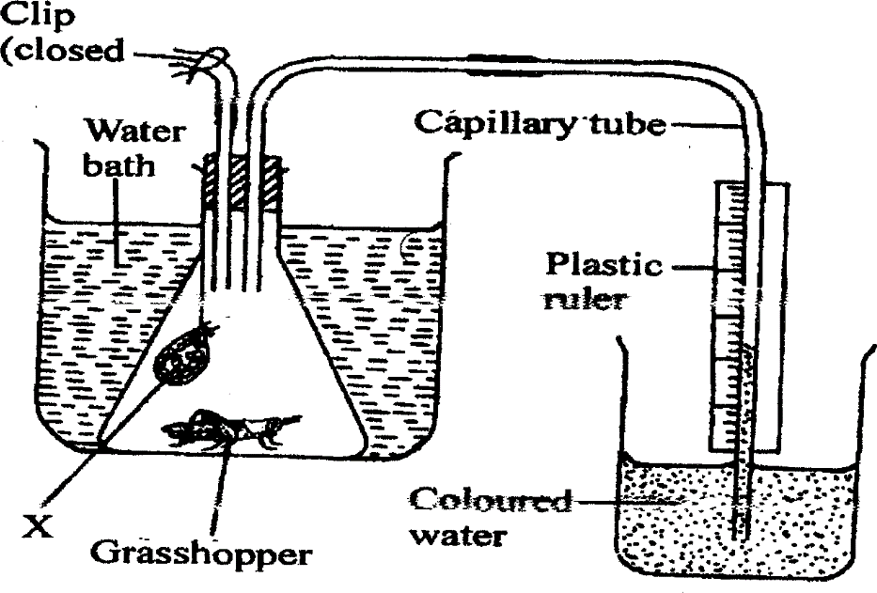The diagram below illustrates and experiment to determine the rate of respiration in a small insect.
2. Name the chemical compound labeled **X** and state its function. (2 marks)

................................................................................................................................................

1. Why is it necessary to place the flask in a water bath? (3 marks)

................................................................................................................................................

................................................................................................................................................

................................................................................................................................................

................................................................................................................................................

...............................................................................................................................................

1. What changes would you expect to observe in the level of coloured water in the capillary tube after the experiment has run for five minutes? (1 mark)

............................................................................................................................................................

............................................................................................................................................................

............................................................................................................................................................

............................................................................................................................................................

1. Explain the changes you have started in (c) above. (3 marks)

................................................................................................................................................

................................................................................................................................................

................................................................................................................................................

................................................................................................................................................

1. State how you can set up a control experiment. (1 mark)

................................................................................................................................................

................................................................................................................................................

**SECTION B ( 40 MARKS)**

1. The data below represents the level of progesterone hormone produced in a female’s body within a period of 34 days. Study the data and use it to answer the questions that follow.

N/B: The days were counted from the 1st day that menstruation was noticed.

|  |  |
| --- | --- |
| Day | Progesterone hormone concentration in arbitrary  units |
| 1 | 6 |
| 2 | 5 |
| 3 | 3 |
| 4 | 2 |
| 5 | 1 |
| 6 | 1 |
| 8 | 1 |
| 10 | 2 |
| 12 | 4 |
| 14 | 7 |
| 16 | 8 |
| 20 | 9 |
| 22 | 10 |
| 24 | 10 |
| 26 | 10 |
| 28 | 10 |
| 30 | 11 |
| 32 | 11 |
| 34 | 11 |

* 1. Plot a graph of progesterone concentration against time using a suitable scale ( 7mrks)



1. Account for the progesterone levels in the blood stream between
   1. Day 1 - day 5 ( 2mrks)

………………………………………………………………………………………………

………………………………………………………………………………………………

………………………………………………………………………………………………

* 1. Day 14 - day 20 ( 2 mrks)

………………………………………………………………………………………………

………………………………………………………………………………………………

………………………………………………………………………………………………

* 1. Day 28 - day 35 (2mrks)

………………………………………………………………………………………………

………………………………………………………………………………………………

…………………………….……………………………………………………………….

1. Name two structures that produce progesterone in females ( 2mrks)

………………………………………………………………………………………………

………………………………………………………………………………………………

1. Suggest the process that usually takes place at day 14 ( 1mrk)

………………………………………………………………………………………………

1. Suggest two other hormones that were in high concentration in the body of the female between days 11 -- 15. Give reasons for your answer. ( 4mrks)

………………………………………………………………………………………………

………………………………………………………………………………………………

………………………………………………………………………………………………

7 a). Explain the mechanism of protein digestion in man (12 mrks)

* 1. Discuss how the following factors affects the distribution of living organism in an ecosystem.
     1. Competition (4mrks)
     2. Wind (4mrks)

1. a) Giving examples discuss how the following evidences of organic evolution show that evolution show that evolution has taken place.
   1. comparative anatomy (6mks)
   2. geographical distribution (4mks)
   3. comparative cell Biology (3mks)

b) Describe how water moves from the soil to the xylem vessels ( 8mrks)

………………………………………………………………………………………………………

………………………………………………………………………………………………………

………………………………………………………………………………………………………

………………………………………………………………………………………………………

………………………………………………………………………………………………………

………………………………………………………………………………………………………

………………………………………………………………………………………………………

………………………………………………………………………………………………………

………………………………………………………………………………………………………

………………………………………………………………………………………………………

………………………………………………………………………………………………………

………………………………………………………………………………………………………

………………………………………………………………………………………………………

………………………………………………………………………………………………………

………………………………………………………………………………………………………

………………………………………………………………………………………………………

………………………………………………………………………………………………………

………………………………………………………………………………………………………

………………………………………………………………………………………………………

………………………………………………………………………………………………………

………………………………………………………………………………………………………

………………………………………………………………………………………………………

………………………………………………………………………………………………………

………………………………………………………………………………………………………

………………………………………………………………………………………………………

………………………………………………………………………………………………………

………………………………………………………………………………………………………

………………………………………………………………………………………………………

………………………………………………………………………………………………………

………………………………………………………………………………………………………

………………………………………………………………………………………………………

………………………………………………………………………………………………………

………………………………………………………………………………………………………

………………………………………………………………………………………………………

………………………………………………………………………………………………………

………………………………………………………………………………………………………

………………………………………………………………………………………………………

………………………………………………………………………………………………………

………………………………………………………………………………………………………

………………………………………………………………………………………………………

………………………………………………………………………………………………………

………………………………………………………………………………………………………

………………………………………………………………………………………………………

………………………………………………………………………………………………………

………………………………………………………………………………………………………

………………………………………………………………………………………………………

………………………………………………………………………………………………………

………………………………………………………………………………………………………

………………………………………………………………………………………………………

………………………………………………………………………………………………………

………………………………………………………………………………………………………

………………………………………………………………………………………………………

………………………………………………………………………………………………………

………………………………………………………………………………………………………

………………………………………………………………………………………………………

………………………………………………………………………………………………………

………………………………………………………………………………………………………

………………………………………………………………………………………………………

………………………………………………………………………………………………………

………………………………………………………………………………………………………

………………………………………………………………………………………………………

………………………………………………………………………………………………………

………………………………………………………………………………………………………

………………………………………………………………………………………………………

………………………………………………………………………………………………………

………………………………………………………………………………………………………

………………………………………………………………………………………………………

………………………………………………………………………………………………………

………………………………………………………………………………………………………

………………………………………………………………………………………………………

………………………………………………………………………………………………………

………………………………………………………………………………………………………

………………………………………………………………………………………………………

………………………………………………………………………………………………………

………………………………………………………………………………………………………

………………………………………………………………………………………………………

………………………………………………………………………………………………………

………………………………………………………………………………………………………

………………………………………………………………………………………………………

………………………………………………………………………………………………………

………………………………………………………………………………………………………